Oreobot 2.0

As of now, we are in the day prior to our last regional competition of the Panamanian WRO. Due to this reason, we knew that we had to get enough points no matter what. Our first version of Oreobot used an Osoyoo Arduino Shield for an Osoyoo Arduino. It was rough to elaborate the code, but it worked in the end. However, we faced many challenges due to the lack of the materials to improve the robot to its fullest capabilities.

We used a 9V Lithium battery that did a great job for most of the time, but when we added the colour sensor, it didn’t have enough power to move the robot. So, it became harder to program the entire thing. For this reason, we decided to use a Lego EV3 robot as an alternative source, being it, Oreobot 2.0.

To build this robot we combined both EV3 LEGO components with some Robot Inventor 51515 LEGO ones, so we kind of have a mutation. Fortunately, realizing the traction system is easier now due to number of possibilities that Lego offers. Also, due to the lack of original batteries, we decided to use AA batteries for our alternative robot.

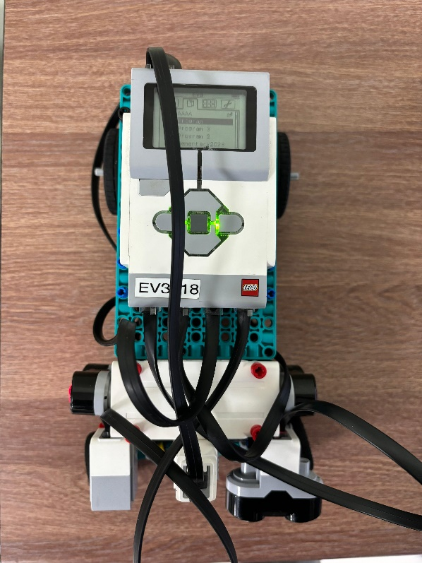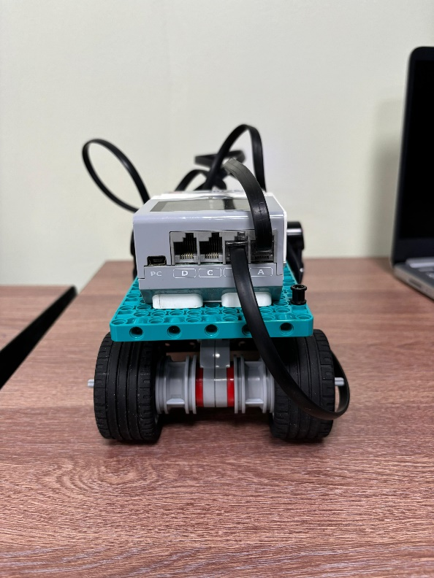

For the sensors we will be using 3 ultrasonic sensors, and a colour one, as the EV3 has only 4 slots for sensors. We decided that it would be better to put the three ultrasonic sensors in the front of the robot so that the measurements would be as accurate as possible. For the colour sensor, we placed it besides the frontal ultrasonic sensor. The frontal and side view of these sensors is the following.

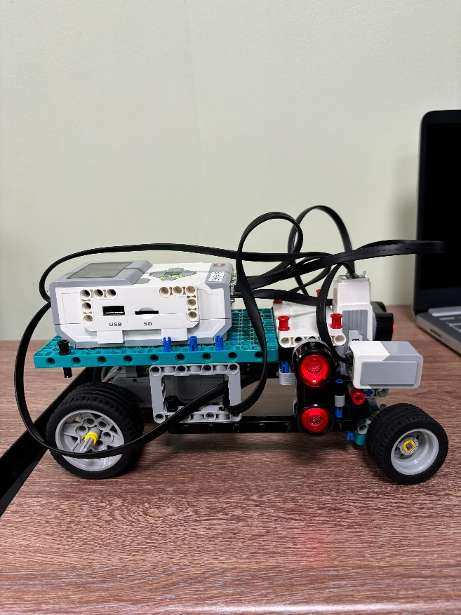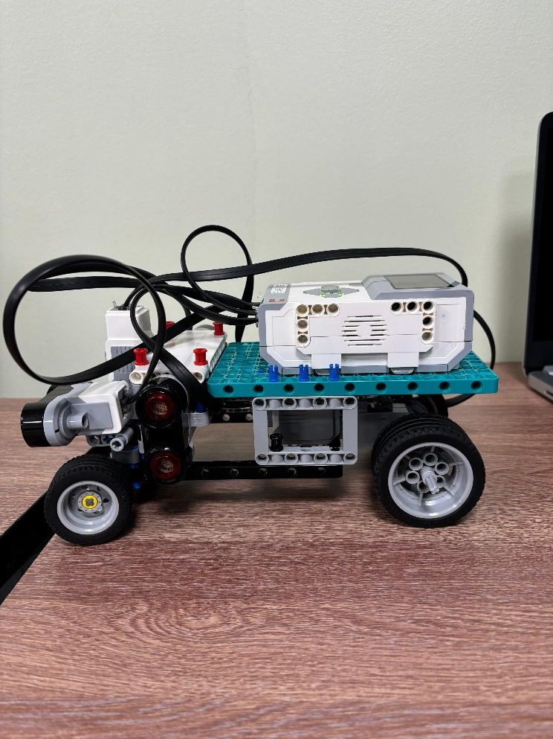

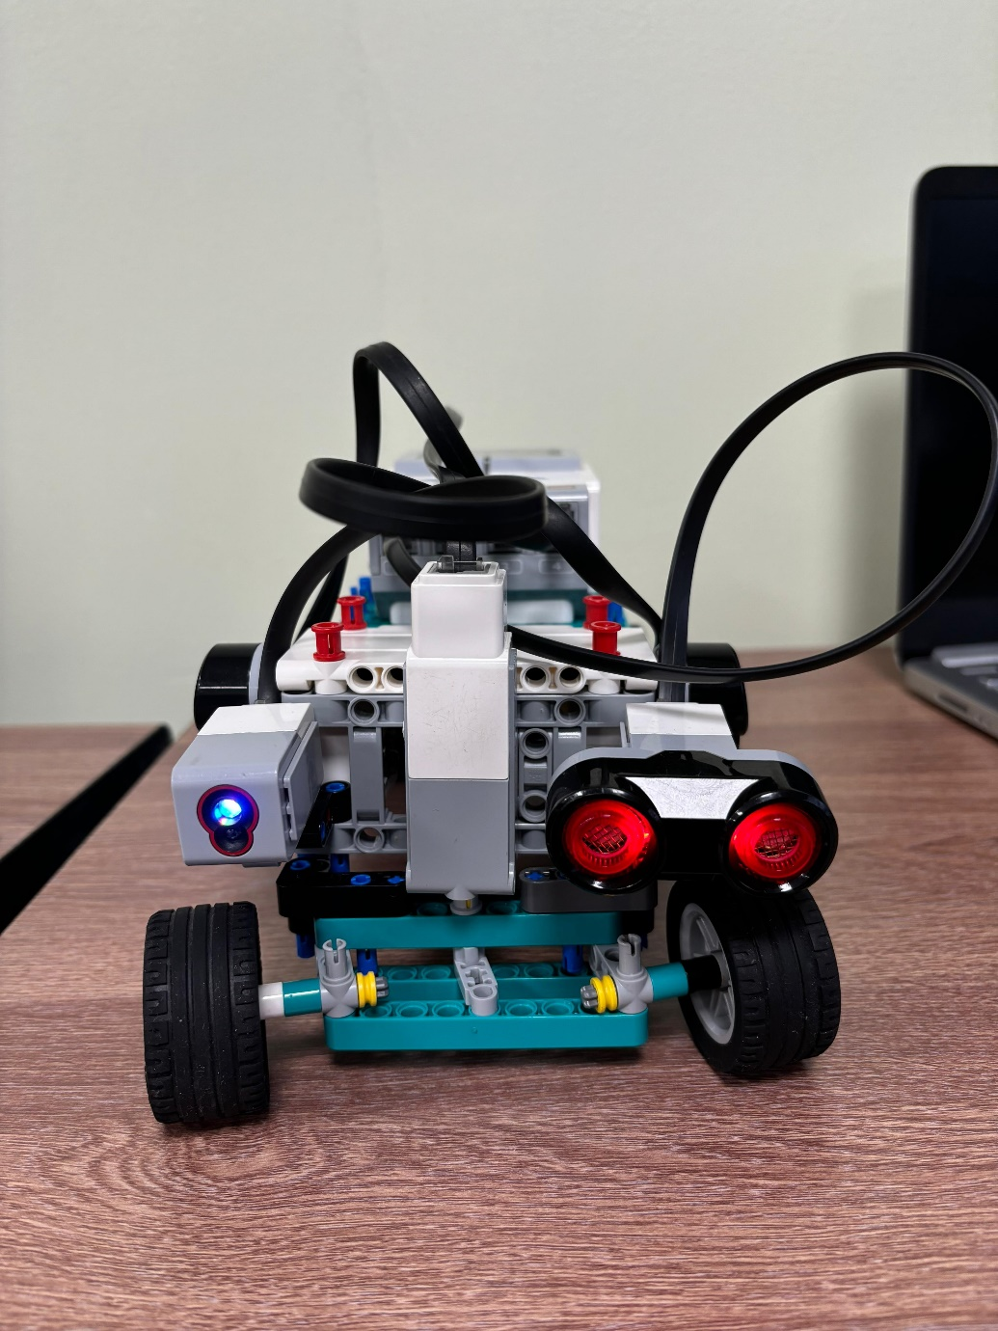

Now, for the movement-related systems we have 2 main ones: The first of them is the one that locks the rear wheels to the motor, and the second one that connects the front wheels to a motor that can change directions. This way we follow the rules as best as possible while our robot remains functional. This is how we elaborated the 2 movement systems.

